Exercise 1:

Modify following code to use verbatim string literal to produce same output.

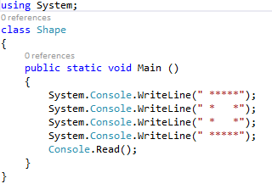

Exercise 2:

Using a class to wrap simple stream input (InputWrapper.cs, provided in the next page), modify following program to calculate area of a triangle given base and height, instead of current hard coded inputs for Base and height.

//Note that base is a keyword, but Base is OK, because C# is case sensitive!

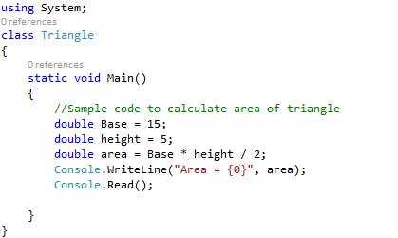
## Note: Enter the following code in a separate class called InputWrapper

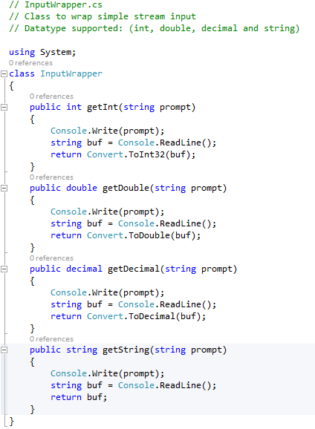
Exercise 3:

Using InputWrapper class from exercise two create a C# console application to determine whether year entered is a leap year. Use a loop in your program to read in years and determine appropriate message to display with following program template. Use -1 is entered to terminate the program.

using System;
public class LeapYearLoop
{
public static int Main(string[] args){
InputWrapper iw = new InputWrapper();

Console.WriteLine("Enter -1 to terminate the program");
int year = iw.getInt("year: ");

while (year != -1)
{
//Write code here to determine & display if a year is //leap year, otherwise display "Not a leap year", then // read another number for a year

}
return 0;
}
}

Exercise 4: Identify Types as Value or Reference
In this exercise, you will write a console application that displays whether objects are value or reference types.

- Using Visual Studio, create a new console application project. Name the project ListValueTypes.

- Create instances of the following classes as shown below:
  - SByte
  - Byte
  - Int16
  - Int32
  - Int64
  - String
  - Exception
The following code demonstrates this:
SByte a = 0;
Byte b =0;
Int16 c = 0;
Int32 d = 0;
Int64 e = 0;
string s = "";
Exception ex = new Exception();

Add each of the instances to a new object array, as the following code demonstrates:
object[] types = { a, b, c, d, e, s, ex };

- Within a foreach loop, check the object.GetType().IsValueType property to
determine whether the type is a value type. Display each type name and whether it is a value type or a reference type, as the following code demonstrates:
foreach ( object o in types )
{
string type;
if (o.GetType().IsValueType)
type = "Value type";
else
type = "Reference Type";
Console.WriteLine("{0}: {1}", o.GetType(), type);
}

- Run the console application, and verify that each type matches your understanding.
Exercise 5: Work with Strings and Arrays

In this exercise, you will write a function to sort a string.

- Using Visual Studio, create a new console application project. Name the project SortString.

- Define a string. Then use the String.Split method to separate the string into an array of words. The following code demonstrates this:
string s = "Microsoft .NET Framework 6.0 Application Development ";
string[] sa = s.Split(' ');

- Call the Array.Sort method to sort the array of words, as the following code demonstrates:
Array.Sort(sa);

- Call the String.Join method to convert the array of words back into a single string, and then write the string to the console. The following code sample demonstrates this:

s = string.Join(" ", sa);
Console.WriteLine(s);

Run the console application, and verify that it works correctly.

Exercise 6: Arrays
Enter the following code into a console C# application to demonstrate different implementations of Arrays. The first example is the myInts Array, which is a single-dimension array. It is initialized at declaration time with explicit values.

Next is a jagged array, myBools. It is essentially an array of arrays. We needed to use the new operator to instantiate the size of the primary array and then use the new operator again for each sub-array.

Third example is an array of strings myStrings, which contains three names.

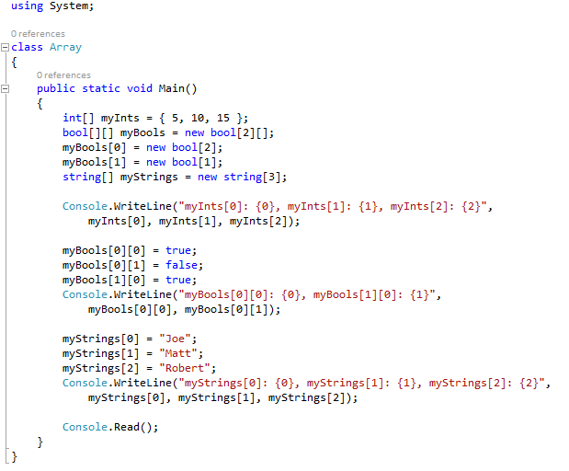
Modify above program to add example to demonstrate use of a two dimensional array with 3 rows & 3 columns called myDoubles.

IT7x22 Lab Sheet 01  Hand this sheet to the lecturer for signing.  Due: Monday 30th July 2018 | Student ID: ___________________  Name : ___________________  Signature: ___________________
I have seen the tasks specified in this lab sheet running.
Signed by: _____________________________ Date: ___________________

